INVITATION

To whom it may concern:
Paris, May 25

Subject: Invitation Letter for Visa Approval

We PSA Groupe certify that Mr./Mrs. ……… holding Saoudi Passport no: ….., the Chief… is invited to attend the Peugeot International Brand Convention organised in Amsterdam (the Netherlands). This event will take place from Monday October 21st, 2019 to Wednesday October 22nd, 2019.
The DoubleTree by Hilton Amsterdam Centraal Station, Oosterdoksstraat 4, 1011 DK Amsterdam, the Netherlands has already been reserved for the period of his stay during the whole Convention.
We would appreciate your visa approval.
Yours sincerely,

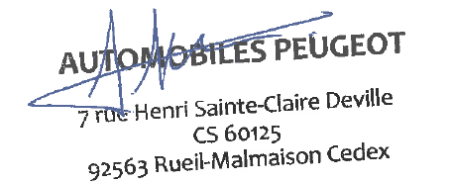

Thierry LONZIANO
Peugeot Global Marketing & Communication Director
Senior VP at PSA Group

7, rue Henri Ste Claire Deville
92563 Rueil-Malmaison, France,

